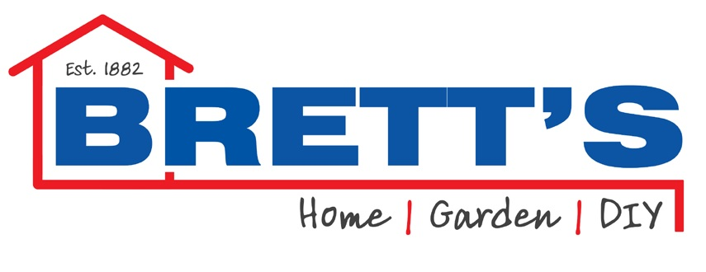

ARE YOU LOOKING FOR A NEW CHALLENGE OR THE NEXT STEP IN YOUR CAREER DEVELOPMENT? ARE YOU INTERESTED IN BECOMING AN IMPORTANT PART OF OUR SALES TEAM?

WE ARE EXCITED IN RECRUITING FOR THE FOLLOWING POSITIONS.

TRADE COUNTER SENIOR SALES IN CALLAN – FULL TIME, PART TIME
Job Duties & Responsibilities:
•Learn the functions and practices of the Trade Counter and become part of the team.
•Have an understanding of building material products and current building regulations.
•Key responsibilities will include serving customers with efficiency and in a positive manner, offering advice to customers in relation to the products they require, handling cash and issuing sales invoices, and dealing with any queries they may have.
The ideal candidate must be willing to learn, be able to take direction, be able to work on their own initiative, and must be able to work as part of a team. Experience in this role is essential.

Please forward your CV with cover letter for all positions to maria@brettshgd.ie

