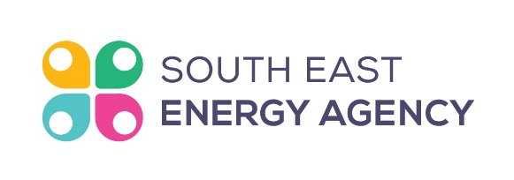

South East Energy Agency
Grants Administrator
We are seeking a highly motivated individual who is passionate about climate action and wanting to join a multi-disciplinary team driven to help achieve the Climate Action Plan 2030 across homes and communities in the South East Region. Experience and passion for grant administration and willing to bring their own unique energy to the team at the Agency in South East Ireland and beyond.
The successful candidate is expected to be responsible for management of the grants on several projects such as SEAI’s National Housing Retrofit and Communities Energy Grants programmes. The grant administrator will ensure the effective flow of information between Head Office, beneficiaries and SEAI, providing overall programme support including administrative plus grant and contract management.
Details
Job Title: Grants Administrator
Application Deadline: March 10th 2023
Working Hours: Full time 5 days a week (37.5 hr), fixed 2-year contract.
Sick Pay and Pension scheme in place.
Salary: €30-42,000.00 depending on experience | Plus Work Phone and Laptop | Business Expenses | Company pension with employer Contribution.
Start Date: ASAP
Location: Head office in Kilkenny, hybrid working model in place
Contract Type: 2-year Fixed Contract with option to extend
Reporting to: Office Manager
How To Apply?
To apply, please complete and return the Application Form available below to Bill Lowe at blowe@southeastenergy.ie with subject line ‘Grants Administrator” telling us more about yourself, your experience/ambitions. Please also indicate your earliest available starting date.

